Amusement Park Enrichment Worksheet Name: ______________________________

1. Amy has $24. How many rides can she go on?

2. This year, the amusement park decided to offer an all day, all-inclusive package for $30.
a. Write an equation to model the all-inclusive offer.

b. Add this second graphical representation to your original graph, which is graphed below.
Amusement Park
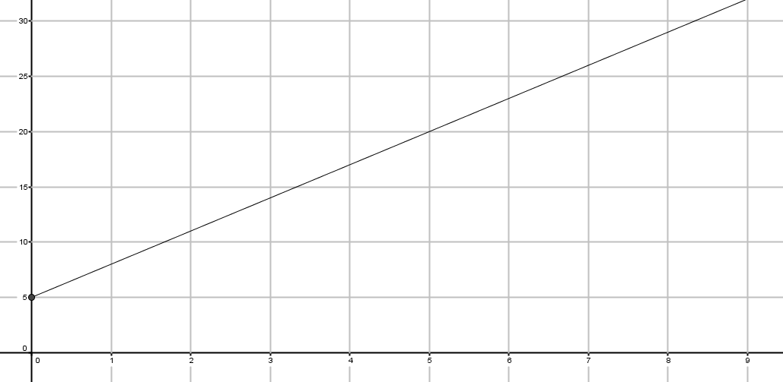

Total Cost

Number of Rides

c. How many rides would you need to ride for the all-inclusive package to be the better deal?

3. Another amusement park prices similarly, with an entrance fee and a cost per ride as given by the graph below.

Another Amusement Park
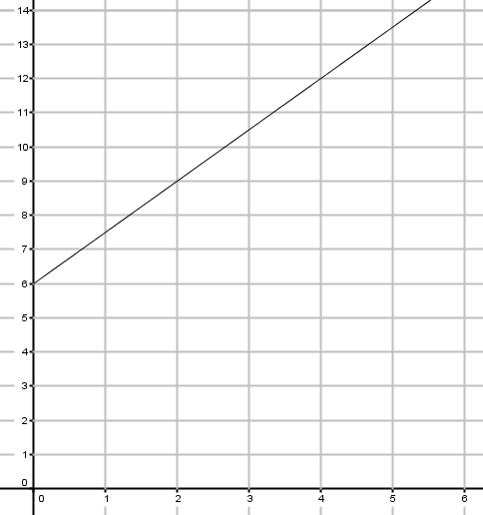
a. What is the entrance fee to this amusement park? Explain how you know.

b. How much does this amusement park charge per ride? Explain how you know.

Total Cost
Rides

